**Download and Install MongoDB**

**Download**

Go to the following link to download the MongoDB:

<https://www.mongodb.com/download-center/community>

By default, The “MongoDB Community Server” is selected, if not, select ““MongoDB Community Server” option.

Choose you OS. For Windows, choose “Windows X64” and click on “Download” button.

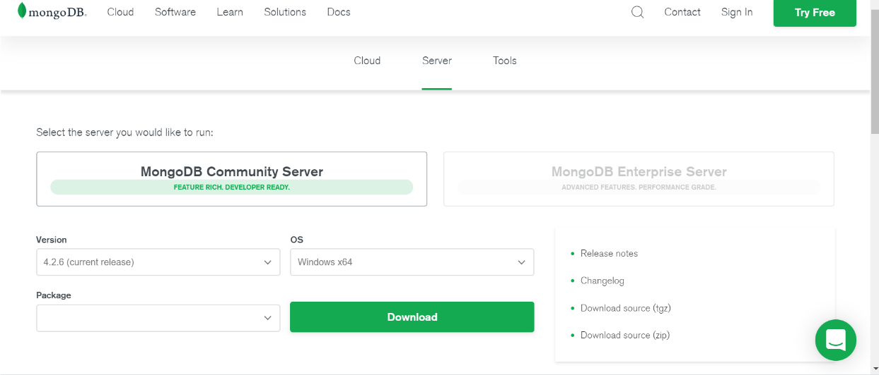

A .msi file will be downloaded.

Install

At the time you install MongoDB, a newer version may be available.

Run the ***.msi*** file. You see the installation wizard. Click on the “Next” button***.***

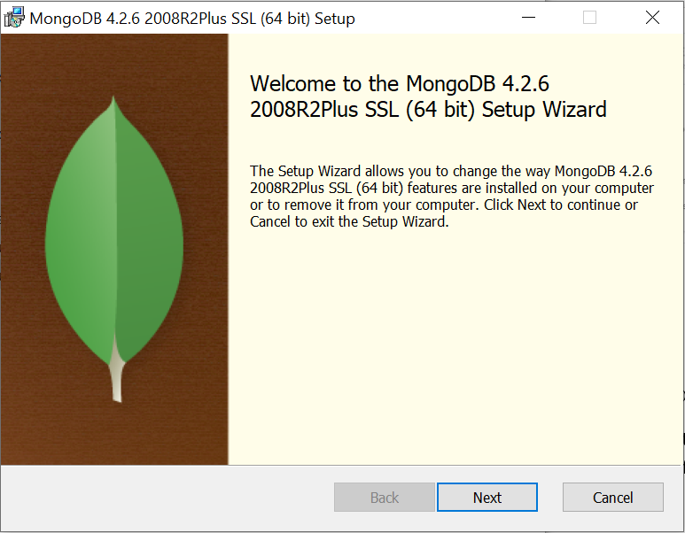

Read and accept the terms in the License Agreement and click on the “Next” button.

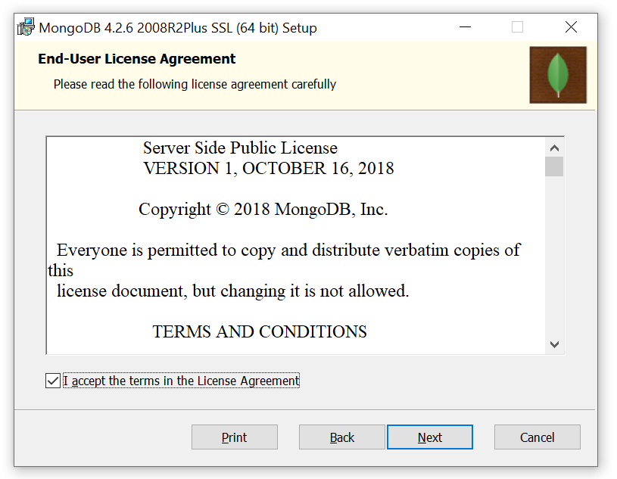

The setup type is “Complete” by default. Choose “Complete”.

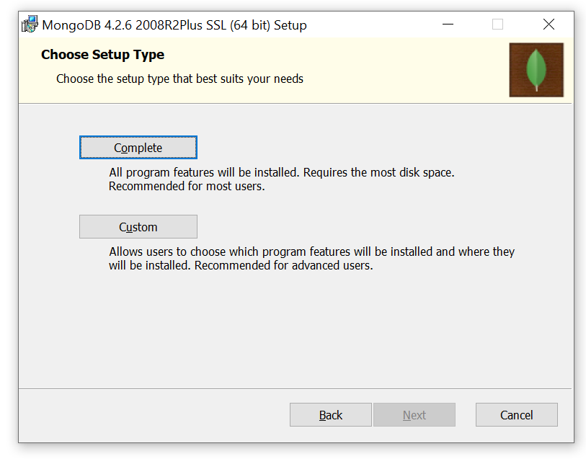

In the Service Configuration page, leave everything as default and do not change anything. Click on the “Next” button.

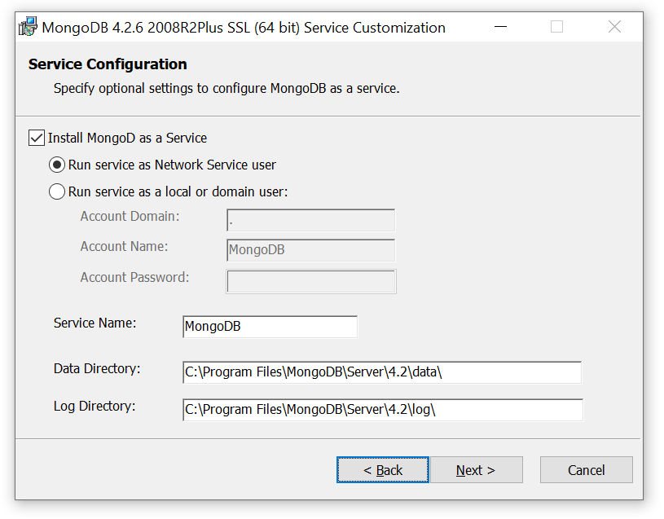

In the next page leave the “Install Mongo Compass” checked and click on the “Next” button.

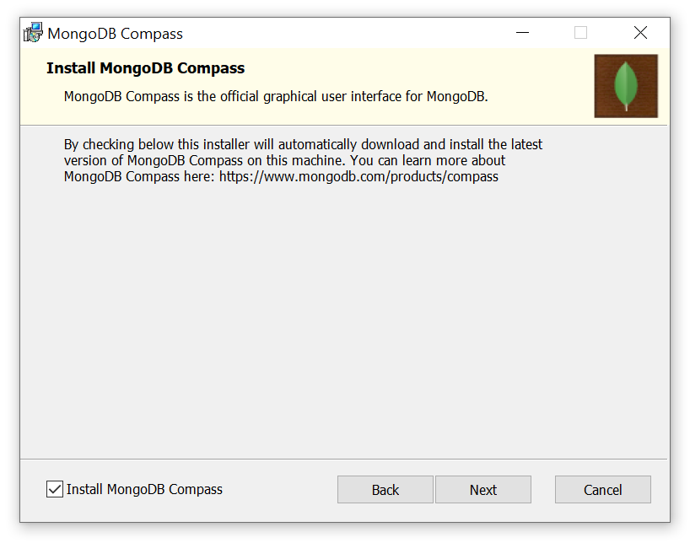

Click on “Install”. When the install process is completed, click on the “Finish” button.

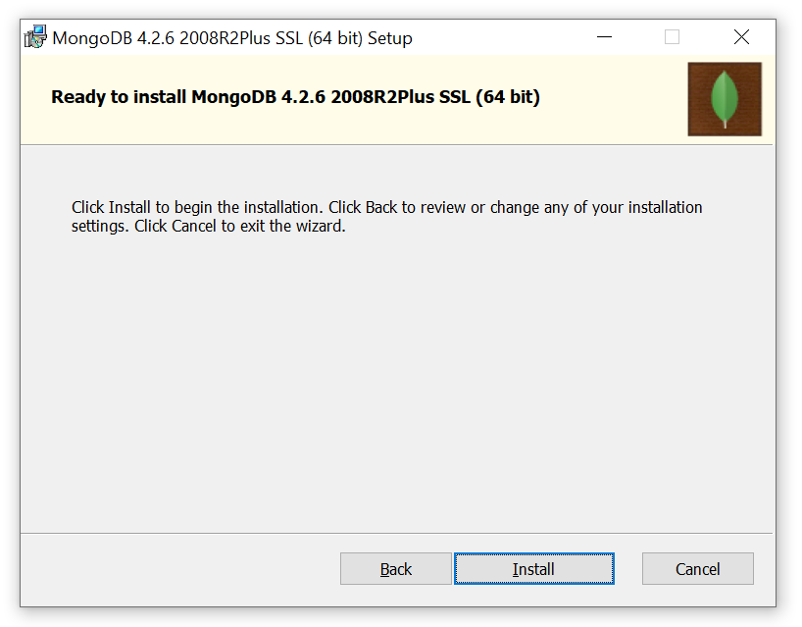

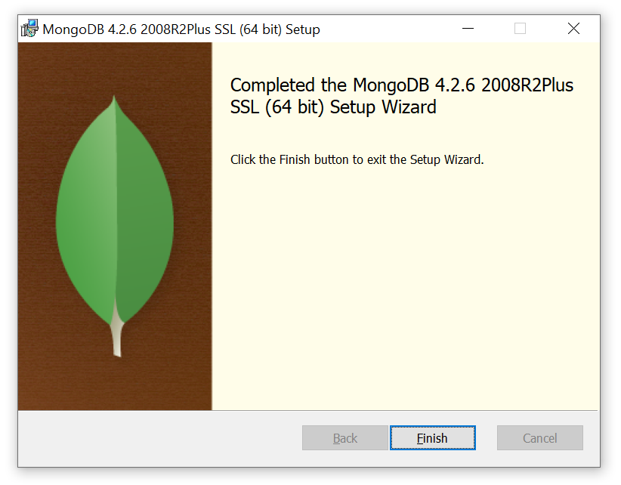

**Run MongoDB**

On your computer, go to the directory where MongoDB is installed and go to the “bin” directory.

C:\Program Files\MongoDB\Server\4.2\bin

You can find MongoDB executable files here:

mongo.exe

mongod.exe

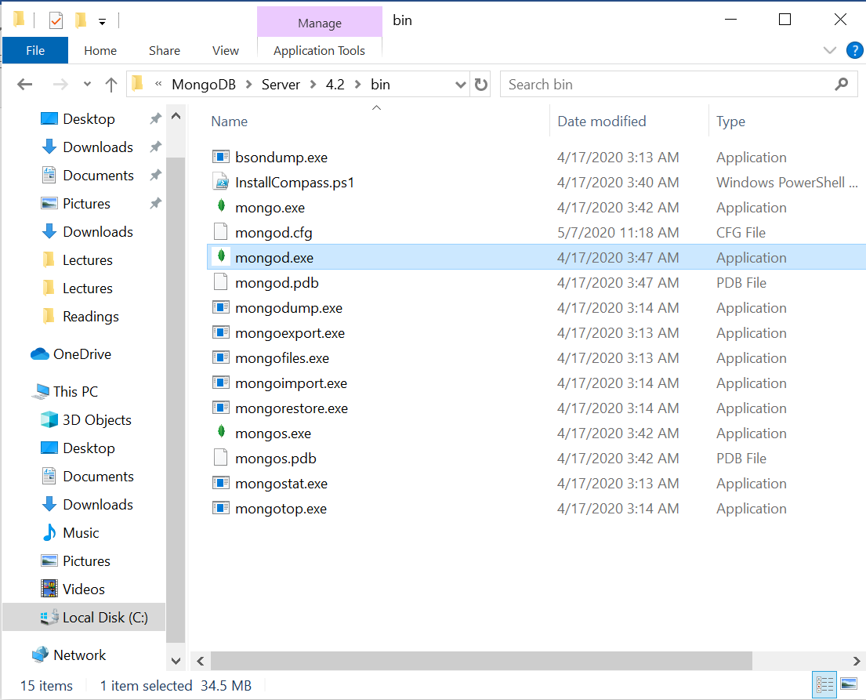

To run MongoDB, open the Windows command prompt and go to the “bin” directory of MongoDB.

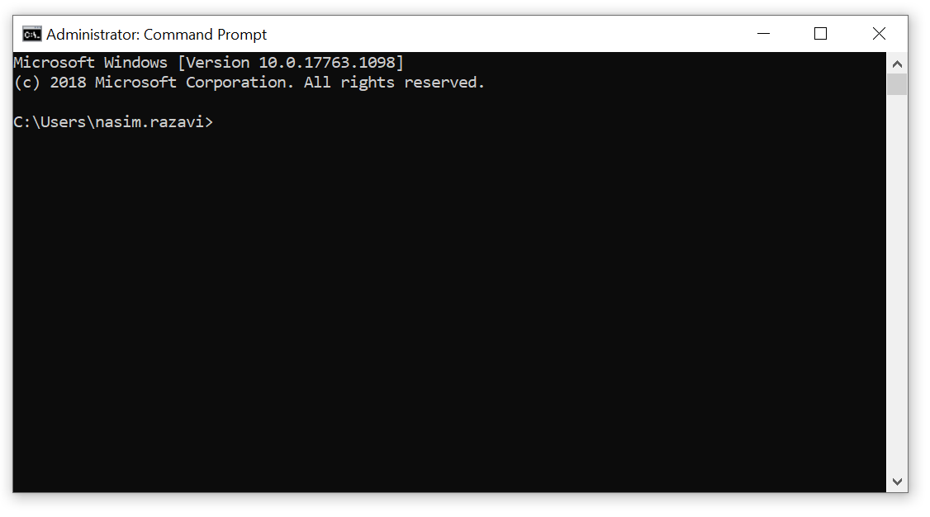

Before you run MongoDB, first create the following directory if it does not exist.

C:\data\db\

Now, execute “mongod” in your command prompt. MongoDB should be running with no errors.

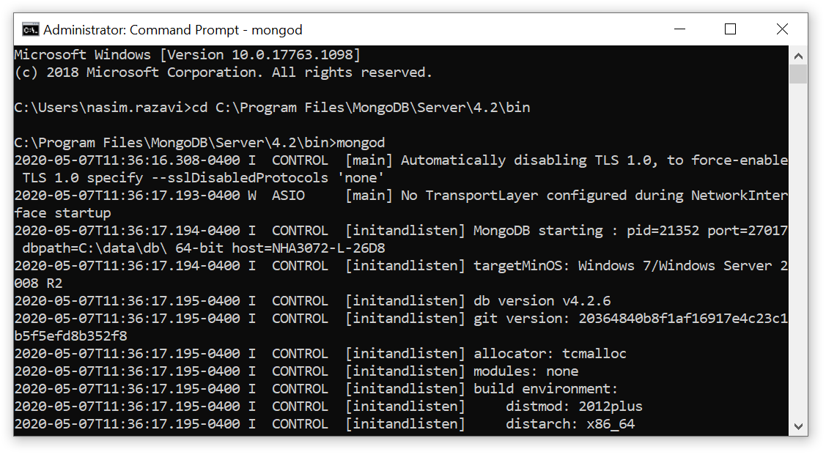

Open a new command prompt. Go to the “bin” directory of MongoDB.

C:\Program Files\MongoDB\Server\4.2\bin

Execute “mongo” in your command prompt which opens the Mongo Client shell.

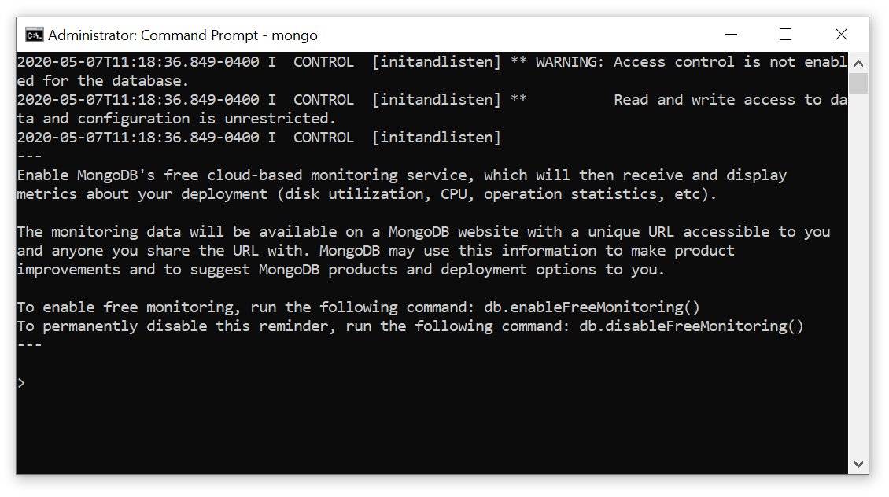

Execute the following command to see all existing databases in your MongoDB:

> show dbs

admin 0.000GB

config 0.000GB

local 0.000GB

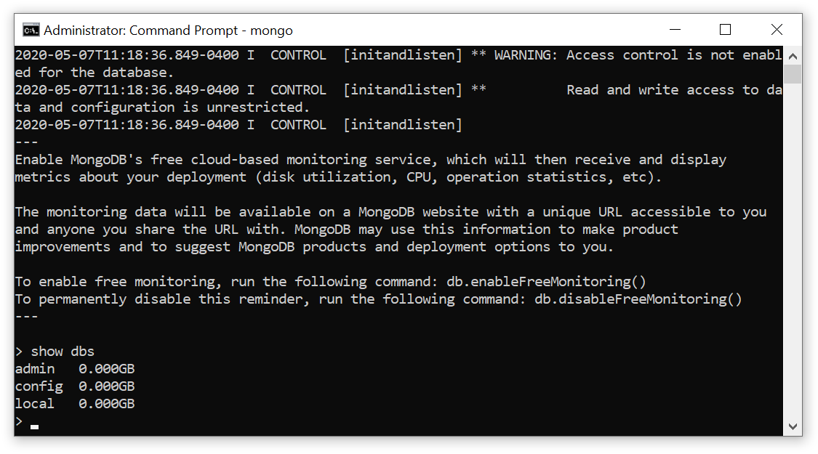

A new MongoDB database is created when you insert data to the database.

To create a new database, execute the following command:

> use library

The “use” command, makes a database your current one. However, since we have not inserted data into the “library” database, you will not see this database as an existing one. We run the “use library” command to tell MongoDB that our current database will be the “library” database.

Now, insert data (a document) into the “library” database.

> db.book.insertOne({"title": "Blue Sky"})

{

"acknowledged" : true,

"insertedId" : ObjectId("5eb42fa3062af495b2bfba9c")

}

“book” is a collection that stores documents. We later learn about collections and documents.

We stored data for a book in our “library” database.

Now, if you show the list of databases, you will see the new database “library” in your list:

> show dbs

admin 0.000GB

config 0.000GB

**library 0.000GB**

local 0.000GB